

Introduction to PATH
(Project for Assistance in Transition from Homelessness)
for Maine HMIS



Contents
Glossary 3
About PATH 4
Mainstream Resources 5
HMIS & PATH 5
PATH Workflow Overview 6
Literal Homelessness 7
PATH Eligibility 7
PATH Outreach & Engagement 8
PATH Enrollment 8
PATH-Funded Services & Referrals (Federal vs. State) 9
PATH Services (An In-depth Look at P1) 9
PATH Referrals (An In-depth Look at P2) 9
PATH Data Collection Stages 10
HUD PATH Data Collection Requirements & Timeliness 13
Appendix A: HUD Data Elements Insights 15
3.01 Name 15
3.02 Social Security Number 15
3.03 Date of Birth 16
3.04 Race 16
3.05 Ethnicity 17
3.06 Gender 17
3.07 Veteran Status 17
3.08 Disabling Condition 18
3.10 Project Start Date 19
3.11 Project Exit Date 19
3.12 Destination 19
3.15 Relationship to Head of Household 20
3.16 Client Location 20
3.917 Prior Living Situation 20
4.02 Income and Sources 21
4.03 Non-Cash Benefits 21
4.04 Health Insurance 22
4.05 Physical Disability 22
4.06 Developmental Disability 23
4.07 Chronic Health Condition 23
4.09 Mental Health Disorder 24
4.10 Substance Use Disorder 24
4.11 Domestic Violence 25
4.12 Current Living Situation (Contact) 25
4.13 Date of Engagement 26
P1 Services Provided (PATH-Funded – Federal) 27
P2 Referrals Provided (PATH-Funded – Federal) 28
P3 PATH Status 29
P4 Connection with SOAR 29
Appendix B: PATH Data Entry into HMIS 29

Glossary

Homeless Management Information System (HMIS): the information system designated by a local Continuum of Care (CoC) to comply with the requirements of CoC Program interim rule 24 CFR 578. It is a locally-administered data system used to record and analyze Client, service, and housing data for individuals and families who are homeless or at risk of homelessness.
Projects for Assistance in Transition from Homelessness (PATH): Federal Grant Program funded by the U.S. Department of Health & Human Services (US DHHS), Substance Abuse & Mental Health Services (SAMHSA) Administration. In Maine, PATH also has a State-Funded Program component. The State-funded PATH Program is administered by the State of Maine Department of Health & Human Services (DHHS), Office of Behavioral Health (OBH).
PATH Eligible: Clients who are literally homeless and have a serious mental illness and/or co-occurring substance use disorder.
Contact: See Current Living Situation…In HMIS, Contacts are now known as Current Living Situation (CLS).
Current Living Situation (CLS): an interaction between the Outreach Worker and Client that is designed to engage the Client. Contacts may include activities such as a conversation with the Client about the Client’s well-being, an office visit to discuss their housing plan, or a referral to another community service. CLS is HUD Data Element 4.12 Current Living Situation.
Date of Engagement: the date on which an interactive Client relationship results in a deliberate Client assessment or the beginning of a case plan. For Federal PATH-Funded Services, data quality is not measured until after the Date of Engagement. Date of Engagement is HUD Data Element 4.13 Date of Engagement.
Enrollment: Enroll only Literally Homeless Applicants that meet one (1) or more of the below requirements, as determined by a Licensed Clinical Supervisor. All such determinations shall be made within six (6) months of the first Outreach:
      - The Case Management Services for Member Experiencing Homelessness eligibility requirements, as stated in 10-144 C.M.R. Ch. 101, Ch. 2, § 13.03-5; and/or
      - The Specific Requirements, as stated in 10-144 C.M.R. Ch. 101, Ch. 2, § 17.02-3; and
      - Has formally consented to participate in Services provided by the PATH Program.
PATH Status Determination: Date on which the Client was determined to be eligible or ineligible for participation in the PATH Program.
‘Enter Data As’ Mode (EDA): The EDA selected determines which Program the Client’s data will be recorded.
PATH EDA: Used to enter data for Street Outreach Clients
PATH Services Only EDA: Used to enter data for Clients that are housed or in shelter
Project Start Date: Date on which Enters the PATH Program. This Entry date will be the date on which the first with the Client occurs. Project Start Date is HUD Data Element 3.10 Project Start Date.
Project Exit Date: Date on which the Client is no longer participating in the PATH Program. Project Exit Date is HUD Data Element 3.11 Project Exit Date.

About PATH

PATH stands for Projects for Assistance in Transition from Homelessness. It is a Federal Grant Program administered by the U.S. Department of Health & Human Services, Substance Abuse and Mental Health Services Administration.
The PATH program is designed to support the outreach, engagement and delivery of services to eligible persons who are homeless and have serious mental illnesses and/or co-occurring substance use disorder with a particular emphasis on:
- Persons most in need of services and/or engagement by an Outreach Worker;
- Services which are not supported by mainstream mental health programs.
The primary target population for PATH-funded Services in Maine will consist of Outreach and Engagement Services to literally homeless persons, youth and adult, who are the hardest to reach and most difficult to engage, with yet unknown severity of mental illness and/or co-occurring substance use disorders.
Enrollment into PATH-funded Services begins with the creation of an electronic record. Persons who meet the PATH homeless definition and who have a mental illness and/or co-occurring substance use disorder may be considered to be eligible for PATH Enrollment.
Mainstream Resources

The principal Mainstream Resources promoted by Maine’s PATH Program are appropriate application to and acceptance of:
- MaineCare (Medicaid) Reimbursable Services, particularly those under Section 17/65 and/or Severe Emotional Disturbance of the MaineCare Benefits Manual;
- Complete and appropriate applications to SSI/SSDI including Appointment of Representative (SSA-1696); and
- Necessary follow-up to ensure eligible persons receive a referral to necessary services such as:
  - Housing Resources such as Section 8, BRAP, Shelter Plus Care, Project Based Housing, VASH, HUD 202/811s, Section 8 Mod-Rehab Housing, Low-Income Housing Tax Credits, and SRO’s;
  - Income resources such as SSI/SSDI, VA Benefits, General Assistance, TANF, Food Stamps, and employment services; and
  - Medical resources such as outpatient primary care, dental, vision, and access to Health Care for the Homeless and/or Federally Qualified Health Centers.

HMIS & PATH

The Homeless Management Information System (HMIS) is an electronic data system that tracks and documents homelessness across the United States and in Maine. Maine’s PATH Program mandates utilization of this system for all persons who receive both Outreach and Engagement Services, as well as PATH-funded Services.
The electronic data management of Maine’s PATH Program will be a shared system. All HMIS Participating Agencies will have access to basic demographic information and Universal Data Elements of all PATH Clients. A list of these Agencies can be found on https://mainehmis.org/Documents under the Agency Forms section. DHHS will have access to all information, both clinical and demographic, on all PATH Enrollees.
Currently, the Maine State Housing Authority is the authorized HMIS Administrator in Maine. To promote coordination of benefits, services and necessary monitoring of PATH requirements, appropriate interagency agreements will be in place and Client releases of information will be obtained so that HMIS data may be appropriately shared among Participating Agencies.
To facilitate utilization of Maine’s HMIS:
- All PATH Sub-recipients must enter into an HMIS/PATH Agency Participation Agreement.
- All PATH Grantee Outreach and Engagement staff must also be equipped with a unique assigned email and cell phone which they can access regularly and be available to respond during standard hours.

PATH Workflow Overview

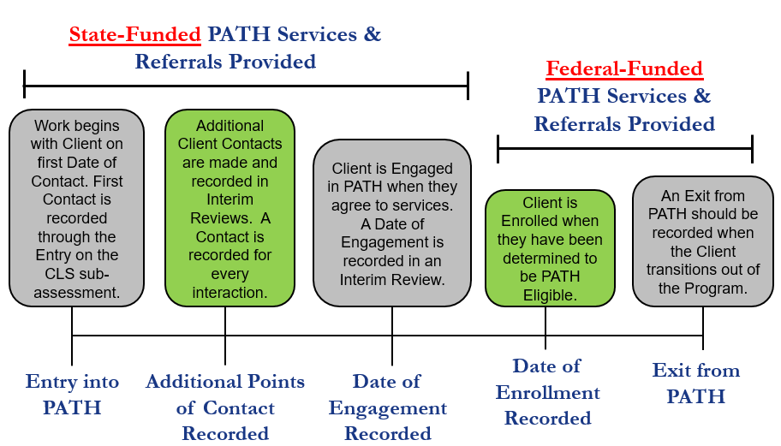

Literal Homelessness

PATH providers are to continue to provide outreach to all individuals who are experiencing literal homelessness with the intent of identifying and engaging those they believe are PATH eligible. PATH outreach services prior to PATH Enrollment should continue without the expectation or burden of the identification of PATH eligibility. The primary focus of the PATH program in Maine is the literal homeless population.
Literally Homeless persons are those individuals who are:
- Sleeping in place not meant for human habitation, such as cars, parks, sidewalks, abandoned buildings or the street;
- Sleeping in an emergency shelter;
- Staying in a hospital or other institution for less than 90 days, if the person was sleeping in an emergency shelter or other place not meant for human habitation immediately prior to entry into the hospital or institution;
- Graduating from, or timing out of, a transitional housing program for homeless persons;
- Victims of domestic violence

PATH Eligibility

The following guidelines are recommended for determining if an individual should be identified as ‘PATH Eligible.’ The individual experiencing homelessness must also be experiencing a Serious Mental Illness or co-occurring Serious Mental Illness and Substance Use Disorder.
Serious Mental Illness: determined through eligibility for services under Section 13/17.
Once an individual is determined to meet the homeless criteria AND the serious mental illness or co-occurring substance use disorder criteria, as defined by the MaineCare Benefits Manual under Section 17.
PATH Outreach & Engagement

The process of bringing literally homeless individuals into treatment and services who are not currently enrolled in such services. Effective outreach strategies should be aimed at engaging persons into the needed array of services. These strategies include: identification of individuals in need, screening, development of rapport, offering support while assisting with immediate and basic needs and, most importantly, referral to and follow-up of those appropriate resources.
Outreach does not occur behind a desk or in an office. The only PATH supported activity that may take place behind a desk or in an office is mandatory data entry into HMIS and reporting to the State and Federal government as requested. This restriction does not prohibit meeting privately with an existing or potential PATH enrolled consumer in a private setting
PATH providers will demonstrate how they will provide outreach and engagement services to homeless persons with mental illness and/or co-occurring substance use disorders.
PATH Enrollment

An individual may be enrolled in PATH when the PATH eligibility criteria are met and the HMIS record contains all universal data elements and other PATH data elements to identify the individual and document some of his/her needs.
PATH Enrollment implies that there is intent to provide services for an individual beyond those provided in outreach AND there is mutual intent for such services to begin. The following standards should be met to consider a Client PATH Enrolled:
- The Worker determined the Client to be PATH Eligible (Client is homeless or at imminent risk of homelessness and meets all eligibility criteria as set forth in the Contract)
- The Client and the PATH Outreach Worker have reached a point in the Engagement process where there is mutual agreement and consent for other Services to begin.
- The PATH outreach Worker has created an individual file and record in HMIS for the Client, which includes at minimum:
- Basic demographic and some Universal Data Elements in HMIS
- Documentation by the Outreach Worker of the rationale of the determination for PATH Eligibility
- Documentation by the Outreach Worker of the Client’s consent for Services
- Documentation by the Outreach Worker of the Services provided
- The Worker recorded at least 1 Contact (CLS) with the Client – this could be the Contact at Project Entry
- The Worker has established a Date of Engagement with the Client (the Date is either on or after the Project Start Date)
PATH-Funded Services & Referrals (Federal vs. State)

Federal PATH-funded Services and Referrals are provided to Enrolled Clients only. Any Services or Referrals provided to the Client prior to Enrollment are considered State-Funded PATH Services and Referrals.
When recording Federal PATH-Funded Services in HMIS, the field “Type of PATH FUNDED Service Provided” will need to be answered.
When recording State-Funded PATH Services, the field “Type of PATH FUNDED Service Provided” will need to be left blank.
The only Federal PATH-Funded Service that should be provided before Enrollment is Outreach, which is recorded as a “Contact” through HUD Data Element 4.12 Current Living Situation.
When recording Federal PATH-Funded Referrals in HMIS, the field “Type of PATH Referral” will need to be answered.
When recording State-Funded PATH Referrals, the field “Type of PATH Referral” will need to be left blank.
Regardless of Funding Type (Federal or State), all Services and Referrals will need to be recorded in HMIS.

PATH Services (An In-depth Look at P1)

The HMIS Data Element P1 Services Provided–PATH Funded is used to determine the PATH-funded Services that are provided to a Client during Project Enrollment, following Project Enrollment through Project Exit.
For every Service provided to the Client, the Service will need to be recorded in HMIS.

PATH Referrals (An In-depth Look at P2)

The HMIS Data Element P2 Referrals Provided–PATH Funded is used to determine the Federally funded Referrals that are provided to a Client during Project Enrollment. A Referral has been Attained once the PATH-Enrolled Client begins receiving Services as the result of PATH assistance.
A PATH Referral is recorded in HMIS each time a Referral is made. Each Referral should be marked as “Attained,” “Not Attained” or “Unknown” as of the Project Exit Date.
•“Attained” means the Client was connected and received the Service (if the Referral is for housing, it is not Attained until the housing placement starts).
•“Not Attained” means the Client was Referred to, but may not have ever been connected with, the Service or did not actually receive the Service.
•“Unknown” means the status of the Client’s connection or receipt of Service is Unknown to the Agency entering the data.

PATH Data Collection Stages
STAGE 1
Outreach
During this first phase, the following data must be collected:

Project Start Date – Date in which Outreach Worker begins working with the Client Contact (Current Living Situation or CLS) – Date and Location
Minimum Data that a Provider can use to identify the Client – This is only necessary if you are unable to collect the Client’s Full Name:
Physical Description (Ex: Five Foot Tall Woman)
Specific Location (Ex: Man Under Bridge)
Clothing/Accessories (Girl Wearing Red Sox Hat)

Project Start Date and the 1st CLS should be the same date. CLS must be recorded in HMIS for every single Contact that occurs.

STAGE 2
Engagement
The following data must be collected on or before Date of Engagement:

Housing StatusNameSSNDOBDate of EngagementMental Health StatusSubstance Use DisorderMaximum UDE’s State-funded ServicesState-funded Referrals
The Date of Engagement is the date in which the Client consents to receiving Services.

//

Enrollment
A Client becomes Enrolled in PATH after they have been determined eligible. At this Stage, the following data must be collected:

Date of PATH Status Determination
All UDE’s
Common Data Elements (Income Sources, Non-Cash Benefits, Health Insurance, Disabilities/Substance Use)
Referrals and Services (PATH-Funded)

Services and Referrals provided prior to the Enrollment Date are State-Funded.
STAGE 3

Exit

An Exit from the PATH Program in HMIS will need to be completed when the Client’s Enrollment in PATH ends.

Project Exit Date – Date on which the Client leaves or completes the PATH Program.
Reasons for Project Exit include:
Client moved into stable permanent housing;
Client transitioned to mainstream resources;
Client leaves the Program or no longer wants to receive PATH Services
No Contact with the Client has occurred within the last 60 days.
Reason for Leaving
Destination
Housing Status
Updates to Common Data Elements (Income Sources, Non-Cash Benefits, Health Insurance, Disabilities/Substance Use)
STAGE 4

HUD PATH Data Collection Requirements & Timeliness

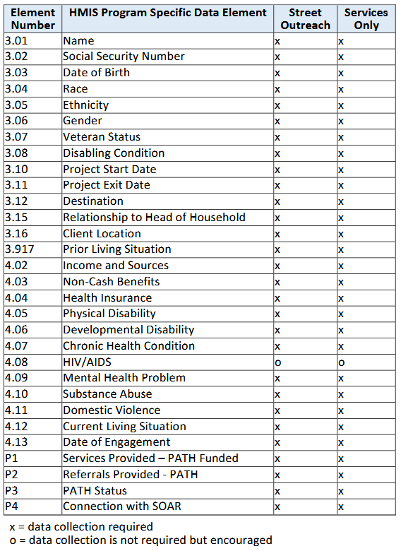
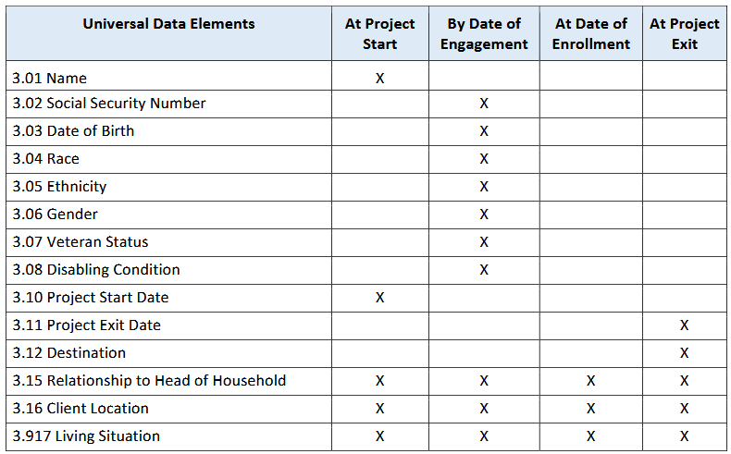
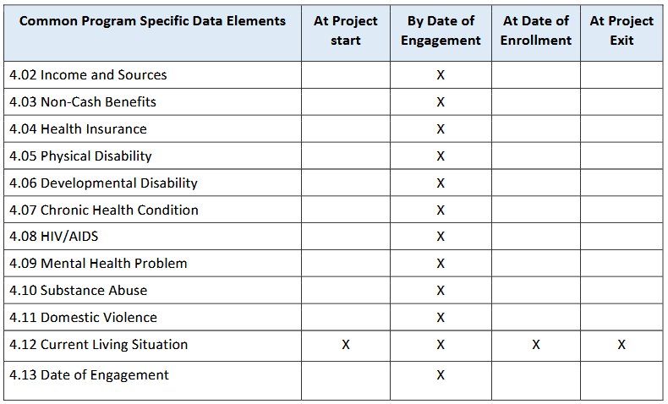
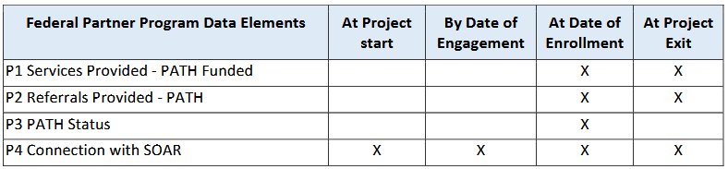

Appendix A: HUD Data Elements Insights

3.01 Name

When creating a new Client record, enter the Client’s name on the ServicePoint Client Search screen and select the appropriate data quality indicator. When enrolling a Client who already has a record in the HMIS, verify that the name in the system is accurate and as complete as possible and correct or complete it if it is not. HMIS records should use a Client’s full, legal name whenever possible. Doing this as a standard practice makes it easier to find records when searching and avoid creating duplicate records.
The PATH Program may record a project entry with limited information about the Client and improve on the accuracy and completeness of Client data over time by editing data in an HMIS as they engage the Client. The initial entry may be as basic as the project entry date, a “made-up” name (e.g., “Redhat Tenthstreetbridge”) that would be identifiable for retrieval by the Worker in the system. Over time, the data must be edited for accuracy (e.g. replacing “Redhat” with “Robert”) as the Worker learns that detail.

3.02 Social Security Number

The Social Security Number (SSN) greatly facilitates the process of identifying Clients who have been served and allows projects to de-duplicate at project start.
Record on the Client Search screen in ClientPoint for new Clients.
Also, an important objective for ending homelessness is to increase access and utilization of mainstream programs by persons who are experiencing homelessness or are at-risk of homelessness. Since SSN is a required data element for many mainstream programs, projects may need the SSN in order to help their Clients access mainstream services.
Some projects may serve Clients that do not have an SSN. In these cases, select 'Client doesn't know.' The federal statute at 5 U.S.C. Section 522a prohibits a government agency from denying shelter or services to Clients who refused to provide their SSN or do not know their SSN, unless the requirement was in effect before 1975 or SSN is a statutory requirement for receiving services from the project.
3.03 Date of Birth

Date of Birth (DOB) is used to calculate the age of persons served at time of project start or at any point during project enrollment and to support the unique identification of each person served.
Record, at Project Start through the Entry assessment, the month, day, and year of birth for every person served. DOB Data Quality should be answered as “Full DOB Reported”.
When enrolling a Client who already has a record in the HMIS, verify that the date of birth on the record is accurate and correct it if it is not.
If the Client cannot remember their birth year, it may be estimated by asking the person's age and calculating the approximate year of birth. If a Client cannot remember the month or day of birth, record an approximate date of '01' for month and '01' for day. When the full DOB is unable to be collected, DOB Data Quality should be answered as ‘Approximate or Partial Date of Birth’.
If a Client is not able to estimate their age within one year of their actual age, select 'Client doesn't know.'
If the Client is able to provide their birth year, but refuses to provide their birth day and month, record an approximate date as indicated above and indicate that the response is ‘Approximate or partial.’
Select ‘Client refused’ when a Client refuses to provide their birth year.
‘Client doesn't know,’ ‘Client refused,’ and ‘Data not collected’ are explanations for missing DOB data. None of these three responses are valid in conjunction with a valid or approximated date entered in ‘Date of Birth.’

3.04 Race

Race is collected to indicate a Client’s self-identification of one or more of five different racial categories. Supports system planning, and local and national understanding of who is experiencing homelessness.
Record, at Project Start through the Entry assessment, the self-identified race(s) of each Client served.
Help the Client select the race or races that they most identify with. Allow Clients to identify as many racial categories as apply (up to five).When enrolling a Client who already has a record in the HMIS, verify that race information is complete and accurate and correct it if it is not. Staff observations should never be used to collect information on race. Provide all options to every Client. Even if staff believes they can guess a Client’s race, every Client must be asked for their self-reported information.
No documentation is required to verify a Client’s response.
‘Client doesn't know,’ ‘Client refused,’ and ‘Data not collected’ are explanations for missing race data. None of these three responses are valid in conjunction with any other response.

3.05 Ethnicity

Record, at Project Start through the Entry assessment, the self-identified ethnicity of each Client served. Help the Client select the ethnicity that they most identify with.
When enrolling a Client who already has a record in the HMIS, verify that ethnicity information is complete and accurate and correct it if it is not.
Staff observations should never be used to collect information on Ethnicity. Even if a staff person believes they can guess a Client’s ethnicity, every Client must be asked for their self-reported information. No documentation is required to verify a Client’s response.

3.06 Gender

Record, at Project Start through the Entry assessment, the self-reported gender of each Client served. When enrolling a Client who already has a record in the HMIS, verify that gender information is complete and accurate -- and correct it if it is not.
Update the gender previously recorded in HMIS if it does not match the person's current gender.
Staff observations should never be used to collect information on gender. Provide all options to every Client. Even if staff thinks they can guess a Client’s gender, every Client must be asked for their self-reported information. If they refuse to give it or say they don't know, do not select a response for the Client.
Gender does not have to match legal documents and Clients may not be asked about medical history or other information to try to determine the person's gender. Simply asking, “Which of these genders best describes how you identify?” is appropriate and focuses on the person's own internal knowledge of their gender.

3.07 Veteran Status

Record, on the ServicePoint Client Search screen for new Clients, whether the Client is a veteran. An HMIS should only have one record of Veteran Status for each Client, no matter how many enrollments they have.
When enrolling a Client who already has a record in the HMIS, verify that the veteran status recorded is accurate and correct it if it is not.
Veteran Status is not dependent on discharge status. A dishonorable discharge limits eligibility for certain VA benefits and programs, but it does not mean that the person is not a veteran for HMIS and PIT purposes.
Unless the project's funder has eligibility requirements for veteran status, it is not necessary to obtain documentation for users to record a 'yes' response to this data element. Asking additional questions may result in more accurate information as some Clients may not be aware that they are considered veterans. For example, “Have you ever been on active duty in the military?” or “Were you disabled during a period of active duty training?”
This data element is only required for adult Clients. There are several options for addressing instances where Clients turn 18 while enrolled:
•Collect the data at the time of enrollment for Clients expected to turn 18 while enrolled; or
•Update the Client record at the time the Client turns 18.

3.08 Disabling Condition

To indicate whether or not Clients have a disabling condition. This data element is to be used with other information to identify whether a Client meets the criteria for chronic homelessness.
Record, at Project Start, whether the Client has a disabling condition at the time of each project start. A disabling condition is one or more of the following:
• A physical, mental, or emotional impairment, including an impairment caused by alcohol or drug abuse, post-traumatic stress disorder, or brain injury that:
1. Is expected to be long-continuing or of indefinite duration;
2. Substantially impedes the individual's ability to live independently; and
3. Could be improved by the provision of more suitable housing conditions.
• A developmental disability, as defined in section 102 of the Developmental Disabilities Assistance and Bill of Rights Act of 2000 (42 U.S.C. 15002); or
• The disease of acquired immunodeficiency syndrome (AIDS) or any condition arising from the etiologic agency for acquired immunodeficiency syndrome (HIV).
Additionally, if the Client is a veteran who is disabled by an injury or illness that was incurred or aggravated during active military service and whose disability meets the disability definition defined in Section 223 of the social security act, they should be identified as having a disabling condition.
It is not necessary to provide documentation to complete this data element. If the Client reports that they have a disabling condition, enter ‘Yes.’ Only projects that receive funding with eligibility criteria that require documentation of the disabling condition should require documentation for enrollment, consistent with those funding requirements.
There should be one and only one value for Disabling Condition for each project stay. If the status changes over the course of the project stay, or the information was recorded incorrectly at the time of the project start, correct the record. The value should always reflect the known status of a Client’s disabling condition.
In addition, a Client indicating the following sources of Income (data element 4.02) can be considered to have a disabling condition: Supplemental Security Income (SSI), Social Security Disability Insurance (SSDI), VA Service-Connected Disability Compensation or VA Non-Service-Connected Disability Pension.
If the answer to this Data Element is “Yes”, please also see Data Element 4.05 Physical Disability.

3.10 Project Start Date

To determine the start of each Client’s period of participation with a project.
Record, at Project Start, the month, day, and year of each Client’s project start. The project start date indicates a Client is now being assisted by the project. For each Client’s enrollment in a project, there must only be one Project Start Date. Any errors in entering the date should be corrected as soon as they are noticed.

3.11 Project Exit Date

To determine the end of a Client’s period of participation with the Project.
Record, at Project Exit, the month, day and year of last day of occupancy or service. For each Client’s enrollment in a project, there should only be one Project Exit Date. Any errors in entering the date should be corrected as soon as they are noticed.
For the PATH Program, the Exit Date must represent the last day a Contact was made or a Service was provided. The Exit Date should coincide with the date the Client is no longer considered a participant in the Project.
The State of Maine PATH Program has determined that Clients should be Exited from HMIS after 60 days without Contact.

3.12 Destination

To identify where a Client will stay just after exiting a project.
Record, at Project Exit, where the Client is expected to stay after they complete or stop participating in project activities. Select the Destination response category that most closely matches where the Client will be staying after exiting the project.
If a Client moves into rental housing with a subsidy to help them maintain the housing, select the response that includes the type of housing subsidy. A housing subsidy may be tenant-, project-, or sponsor-based and provides ongoing assistance to reduce rent burden. This includes housing subsidies provided through HUD-funded subsidies (e.g., public housing, Housing Choice Voucher or “Section 8”) or other housing subsidy (e.g., state rental assistance voucher).
If a Client moves in with family or friends, select the response that includes the expected tenure of the destination (permanent or temporary). There is no specific timeframe used to differentiate between 'permanent' or 'temporary.' Rather, the determination should be made based on whether the situation reflects family reunification or whether the family member or friend has placed any limitation that indicates the stay is intended to be temporary (e.g. a specific time limit).
'Other' should be used only as a last resort if the Client’s destination truly cannot be even loosely described by any of the available options. Any response of 'Other' will not count in any HMIS-based reporting as a positive outcome.
Prior Living Situation data should not be used as the source for Destination, Destination should not be pre-filled at project start, and unconfirmed, word of mouth-type information should not be used as a source for Destination responses in HMIS.

3.15 Relationship to Head of Household

For the PATH Program, the individual Client must be identified as the Head of Household by selecting “Self (head of household)”. This must be recorded at Project Start through the Entry assessment. As a reminder, the Maine PATH Program does not collect or record information on households. The PATH Program is intended to serve individuals only.

3.16 Client Location

To link Client household data to the relevant CoC. This field has one option in the drop-down list: ME-500 for the State of Maine.

3.917 Prior Living Situation

To identify the type of living situation and length of stay in that situation just prior to Project Start.
The responses are intended to reflect from the Client’s last living situation immediately prior to the Project Start Date. For PATH, the 'prior' living situation may be the same as the Client’s current living situation.
There are a few fields that will need to be completed in order to fully answer this data element. Those fields require the Worker to:
- Record the actual or approximate date this homeless situation began (i.e. the beginning of the continuous period of homelessness on the streets, in emergency shelters, in safe havens, or moving back and forth between those places).
- Record the number of times the Client has been on the streets, in emergency shelters, or in safe havens in the past three years, including today.
- Record the cumulative total number of months the Client has been homeless on the streets, in emergency shelters, or in safe havens in the past three years.

4.02 Income and Sources

To determine whether households are accessing all income sources for which they are eligible at the time of project start. Increase in income is a key performance measure of most Federal Partner programs. Collecting income information throughout a project stay supports plans to link Clients with all income sources and benefits for which they are eligible.
Indicate, at Project Start, Update and Project Exit, whether a Client is receiving an Income Source by completing the HUD Verification and recording all sources of income being received. An Income and Sources record must be created at any time during a project stay if income or sources change
Income data should be recorded only for sources of income that are current as of the 'Information Date'. Clients may identify multiple sources of income.
When a Client has income, but does not know the exact amount, a 'Yes' response should be recorded for both the overall income question and the specific source, and the income amount should be estimated. Income and Sources is intended to identify regular, recurrent earned income and cash benefits.
Services and/or gifts such as phone cards and vouchers that are provided by a project to Clients during enrollment are fundamentally different and are not considered income.
Student financial aid is not to be considered income unless the financial aid includes a cash stipend. The source for such income would be considered ‘Other,’ and the source can be described in a text field.
Lump sum amounts received by a family, such as inheritances, insurance settlements, or proceeds from sale of property, or back pay from Social Security are considered assets, not income, and are not recorded in HMIS.

4.03 Non-Cash Benefits

To determine whether households are accessing all mainstream program benefits for which they are eligible at the time of project start.
Indicate, at Project Start, Update and Project Exit, whether Client is receiving any of the listed benefits by completing the HUD Verification and recording all sources of Non-Cash Benefits being received.
Non-Cash Benefits collected at project start and project exit are to reflect the information as of the date of project start and the date of project exit. A Non-Cash Benefits record must be created at any time during a project stay if non-cash benefits change.
Benefits data should be recorded only for benefits that are current as of the 'Information Date'. Clients may identify multiple sources of non-cash benefits.
Non-Cash Benefits is intended to identify regular, recurrent benefits.
Services and/or gifts such as phone cards and vouchers that are provided by a project to Clients during enrollment are fundamentally different and are not considered benefits.

4.04 Health Insurance

To determine whether Clients are accessing all mainstream medical assistance benefits for which they may be eligible.
Indicate, at Project Start, Update and Project Exit, whether or not Clients are receiving health insurance from any of the listed sources by completing the HUD Verification and recording all sources of Health Insurance sources the Client is covered by.
A Health Insurance record must be created at any time during a project stay if health insurance coverage information changes. 'Information Date' for those records must reflect the date of the data collection.
Applying for coverage through a healthcare exchange could result in a person receiving subsidized private health insurance or it could result in the person receiving Medicaid. If the Client’s health coverage is through a private provider (even if it is heavily subsidized), record it as Private Pay Health Insurance. If the Client’s health coverage is through Medicaid (even if it was accessed through a healthcare exchange website), record it as Medicaid.
Health Insurance is intended to identify actual health insurance sources. Indigent care received by a medical provider or hospital to cover a health care costs does not constitute health insurance coverage and should not be recorded in HMIS.

4.05 Physical Disability

To indicate whether Clients have any disabling special needs which contribute to their experience of homelessness or may be a factor in housing.
Indicate, at Project Start, Update and Project Exit, the following by completing the HUD Verification for Health, Substance Use and Disabilities:
1. If each Client has the indicated disability; and
2. If there is indication that the disability is expected to be of long-continued and indefinite duration and substantially impair the Client’s ability to live independently (applicable to 4.05, 4.07, 4.09, and 4.10 only).
Individual Disability records created at project start, update, and project exit are to reflect the information as of the date of each phase of data collection. Disability update records should be created at any time during a project stay if a Client’s disability status changes. 'Information Date' for those records must reflect the date of project start, update, and the date of project exit, respectively. If a Client’s disability status was recorded incorrectly at entry, update, or exit, correct the existing record rather than creating a new update record.
Unless the project funder requires documentation for record keeping purposes, Clients are not required to provide documentation of the disability, nor does entering the information in the HMIS constitute a “diagnosis” by the Worker who did the data collection or recording. If the disability is present and is expected to be of long-continued and indefinite duration, the corresponding element 3.08 Disabling Condition should also be ‘Yes’.
It is acceptable for a Client to answer 'Yes' to having a physical disability, and also answer 'No,' that the disability is not expected to be of long, continued, and indefinite duration and substantially impair ability to live independently, although a disability of such type may not qualify Clients for programs meant for severely disabled people and may not indicate a Disabling Condition according to the universal data element 3.08 Disabling Condition.

4.06 Developmental Disability

To indicate whether Clients have any disabling special needs which contribute to their experience of homelessness or may be a factor in housing.
Indicate, at Project Start, Update and Project Exit, if each Client has a Developmental Disability by completing the HUD Verification for Health, Substance Use and Disabilities.
Individual Disability records created at project start, update, and project exit are to reflect the information as of the date of each phase of data collection. Disability update records should be created at any time during a project stay if a Client’s disability status changes. 'Information Date' for those records must reflect the date of project start, update, and the date of project exit, respectively. If a Client’s disability status was recorded incorrectly at entry, update, or exit, correct the existing record rather than creating a new update record.
Unless the project funder requires documentation for record keeping purposes, Clients are not required to provide documentation of the disability, nor does entering the information in the HMIS constitute a “diagnosis” by the Worker who did the data collection or recording.
If a Developmental Disability is present, the corresponding element 3.08 Disabling Condition should also be “Yes”.

4.07 Chronic Health Condition

To indicate whether Clients have any disabling special needs which contribute to their experience of homelessness or may be a factor in housing.
Indicate, at Project Start, Update and Project Exit, the following by completing the HUD Verification for Health, Substance Use and Disabilities:
1. If each Client has the indicated disability; and
2. If there is indication that the disability is expected to be of long-continued and indefinite duration and substantially impair the Client’s ability to live independently
Individual Disability records created at project start, update, and project exit are to reflect the information as of the date of each phase of data collection. Disability update records should be created at any time during a project stay if a Client’s disability status changes. 'Information Date' for those records must reflect the date of project start, update, and the date of project exit, respectively. If a Client’s disability status was recorded incorrectly at entry, update, or exit, correct the existing record rather than creating a new update record.
Unless the project funder requires documentation for record keeping purposes, Clients are not required to provide documentation of the disability, nor does entering the information in the HMIS constitute a “diagnosis” by the Worker who did the data collection or recording.
If the disability is present and is expected to be of long-continued and indefinite duration, the corresponding element 3.08 Disabling Condition should also be “yes” whether by manual data entry, or in some systems, automatic population. It is acceptable for a Client to answer "Yes" to having a disability, and also answer "No," that the disability is not expected to be of long, continued, and indefinite duration and substantially impair ability to live independently, although a disability of such type may not qualify Clients for programs meant for severely disabled people and may not indicate a “disabling condition” according to the universal data element 3.08.

4.09 Mental Health Disorder

To indicate whether Clients have any disabling special needs which contribute to their experience of homelessness or may be a factor in housing.
Indicate, at Project Start, Update, and Project Exit, the following by completing the HUD Verification for Health, Substance Use and Disabilities:
1. If each Client has the indicated disability; and
2. If there is indication that the disability is expected to be of long-continued and indefinite duration and substantially impair the Client’s ability to live independently
Individual Disability records created at project start, update, and project exit are to reflect the information as of the date of each phase of data collection. Disability update records should be created at any time during a project stay if a Client’s disability status changes. 'Information Date' for those records must reflect the date of project start, update, and the date of project exit, respectively. If a Client’s disability status was recorded incorrectly at entry, update, or exit, correct the existing record rather than creating a new update record.
Unless the project funder requires documentation for record keeping purposes, Clients are not required to provide documentation of the disability, nor does entering the information in the HMIS constitute a “diagnosis” by the Worker who did the data collection or recording.
If the disability is present and is expected to be of long-continued and indefinite duration, the corresponding element 3.08 Disabling Condition should also be “yes” whether by manual data entry, or in some systems, automatic population. It is acceptable for a Client to answer "Yes" to having a disability, and also answer "No," that the disability is not expected to be of long, continued, and indefinite duration and substantially impair ability to live independently, although a disability of such type may not qualify Clients for programs meant for severely disabled people and may not indicate a “disabling condition” according to the universal data element 3.08.

4.10 Substance Use Disorder

To indicate whether Clients have any disabling special needs which contribute to their experience of homelessness or may be a factor in housing.
Indicate, at Project Start, Update and Project Exit, the following by completing the HUD Verification for Health, Substance Use and Disabilities:
1. If each Client has the indicated disability; and
2. If there is indication that the disability is expected to be of long-continued and indefinite duration and substantially impair the Client’s ability to live independently
Individual Disability records created at project start, update, and project exit are to reflect the information as of the date of each phase of data collection. Disability update records should be created at any time during a project stay if a Client’s disability status changes. 'Information Date' for those records must reflect the date of project start, update, and the date of project exit, respectively. If a Client’s disability status was recorded incorrectly at entry, update, or exit, correct the existing record rather than creating a new update record.
Unless the project funder requires documentation for record keeping purposes, Clients are not required to provide documentation of the disability, nor does entering the information in the HMIS constitute a “diagnosis” by the Worker who did the data collection or recording.
If the disability is present and is expected to be of long-continued and indefinite duration, the corresponding element 3.08 Disabling Condition should also be “yes” whether by manual data entry, or in some systems, automatic population. It is acceptable for a Client to answer "Yes" to having a disability, and also answer "No," that the disability is not expected to be of long, continued, and indefinite duration and substantially impair ability to live independently, although a disability of such type may not qualify Clients for programs meant for severely disabled people and may not indicate a “disabling condition” according to the universal data element 3.08.

4.11 Domestic Violence

To indicate whether the Client is a survivor of Domestic Violence.
Indicate, at Project Start and through Interims as an Update, the following:
1. If the Client is a survivor of domestic violence,
2. When the experience occurred, and
3. If the Client is currently fleeing domestic violence.
Domestic Violence records created at project start are to reflect the information as of the date of project start. 'Information Date' for those records must reflect the date of project start.
A Domestic Violence record must be created at any time during a project stay if a Client’s domestic violence status changes. 'Information Date' for those records must reflect the date of the data collection.
If a Client’s domestic violence status was recorded incorrectly at project start, correct the existing record.
Verification is not necessary unless it is specifically required for project eligibility, in which case documentation requirements established by the funder should be followed.

4.12 Current Living Situation (Contact)

To record each contact with people experiencing homelessness by street outreach and other service projects and to provide information on the number of contacts required to engage the Client, as well as to document a current living situation.
Record, at occurrence, the date and location of each interaction with a Client by recording their Current Living Situation. The first Current Living Situation with the Client will occur at the same point as Project Start Date.
All street outreach projects are expected to record every contact made with each Client by recording their Current Living Situation, including when the Project Start Date, Prior Living Situationor Date of Engagement is recorded on the same day. There may or may not be a contact made at project exit.
Contacts that require the collection of Current Living Situation include activities such as a conversation between a street outreach Worker and Client about the Client’s well-being or needs, an office visit to discuss their housing plan, or a referral to another community service.
Data Collection requirements for PATH-funded components is limited to the following fields from the Living Situation Options List:
•Place not meant for habitation (e.g. a vehicle, an abandoned building, bus/train/subway station/airport or anywhere outside)
•Emergency shelter, including hotel or motel paid for with emergency shelter voucher, or RHY-funded Host Home shelter
•Safe Haven
•Other
•Worker unable to determine

4.13 Date of Engagement

To record the date the Client became 'engaged' in project services after one or more contacts with the PATH Worker.
Record, at occurrence, the date a Client became engaged, by PATH Worker, in the development of a plan to address their situation.
Only one date of engagement is allowed between Project Start and Exit. This date may be on or after the Project Start Date, but must be on or prior to the Project Exit Date.
If the project has not developed this intensive relationship with the Client before exit, Date of Engagement should be left blank.
If the Client returns after a project exit, a new Project Start Date and a new Date of Engagement is to be established.
Reporting on data quality for PATH is limited to Clients with a Date of Engagement.
All Universal Data Elements and applicable Program Specific Data Elements should be reviewed for completeness and accuracy on the Date of Engagement.

P1 Services Provided (PATH-Funded – Federal)

Record the following as it occurs:
- Date of Service
- Type of PATH-Funded Service Provided
Type | Description
Re-engagement | Process of engaging with PATH-Enrolled Clients who are disconnected from PATH Services.
Screening | An in-person process during which preliminary evaluation is made to determine a person’s needs and how they can be addressed through the PATH Program.
Clinical Assessment | A clinical determination of psychosocial needs and concerns.
Habilitation/ Rehabilitation | Services that help the PATH Client learn or improve the skills needed to function in a variety of Activities of Daily Living (ADL’s).
Community Mental Health | A range of mental health and/or co-occurring Services and activities provided in non-institutional settings to facilitate an individual’s recovery. Note: This category does not include case management, alcohol/drug treatment, or habilitation/rehabilitation as they are stand-alone Services with distinct definitions.
Substance Use Treatment | Preventative, diagnostic, and other Services and supports provided for people who have a psychological dependence on one or more substances.
Case Management | A collaboration between a Service Recipient and a Provider in which advocacy, communication, and Resource Management are used to design and implement a wellness plan specific to the PATH-Enrolled Client’s needs.
Residential Support Services | Services that help PATH-Enrolled Clients practice the skills necessary to maintain residence in the least restrictive community-based settings possible.
Housing – Minor Renovation | Services, resources, or small repairs that ensure a housing unit is physically accessible and/or that health or safety hazards have been mitigated or eliminated.
Housing Moving Assistance | Funds and other resources provided on behalf of a PATH-Enrolled Client to help establish that Client’s home. Note: This excludes Security Deposits and one-time rental payments.
Housing Eligibility Determination | The process of determining whether the Client meets financial and other requirements to enter into public or subsidized housing.
Security Deposits | Funds provided on behalf of the PATH-Enrolled Client to pay up to 2 months’ rent or other security deposits in order to secure housing.
One-time Rent for Eviction Prevention | One-time payment on behalf of the PATH-Enrolled Client who is at risk of eviction without this financial assistance.
P2 Referrals Provided (PATH-Funded – Federal)

Record the following as it occurs:
- Date of Referral
- Type of PATH-Funded Referral Provided: The PATH Worker provides support on behalf of, or in conjunction with, the PATH-Enrolled Client to connect the Client to an appropriate Agency, Organization, or Service that:
Type | Description
Community Mental Health | Stabilizes, supports, or treats people for mental health disorders or co-occurring mental health and substance use disorders
Substance Use Treatment | Offers preventative, diagnostic, and other Services and supports for individuals who have psychological and/or physical problems with use of one or more substances
Primary Health/ Dental Care | Offers physical and/or dental health care Services
Job Training | Helps prepare the Client to gain and maintain the skills necessary for paid or volunteer work
Educational Services | Offers academic instruction and training
Housing Services | Offers assistance with attaining and sustaining living accommodations
Temporary Housing | Offers shelter in a time-limited setting
Permanent Housing | Offers residence in a stable setting where length of stay is determined by the Client without limitations, as long as they meet the basic requirements of tenancy
Income Assistance | Offers benefits that provide financial support
Employment Assistance | Offers assistance designed to lead to compensated work
Medical Insurance | Offers coverage that provides payment for wellness or other services needed as a result of sickness, injury, or disability

- Outcome
- Attained: Client was connected and received the Service – if the Referral is for Housing, it is not attained until the housing placement starts.
- Not Attained: Either the Client was referred to, but may not have ever been connected with, the Service or the Client did not actually receive the Service.
- Unknown: The status of the Client’s connection or receipt of the Service is unknown to the PATH Worker.
P3 PATH Status

Record at occurrence:
- Date of PATH Status Determination
- Client Became Enrolled in PATH: Yes or No
  - If ‘No’, record “Reason Not Enrolled”

P4 Connection with SOAR

Record at Project Start, Update and Exit:
- Connection with SOAR:
  - Yes
  - No
  - Client Doesn’t Know
  - Client Refused
  - Data Not Collected

Appendix B: PATH Data Entry into HMIS
Each Client participating in the PATH Program must have an Entry into HMIS. As needed, Updates to Client information is recorded via Interim Reviews. When the Client completes or leaves the PATH Program, an Exit from the Program will need to be recorded in HMIS.
After logging into HMIS, the first step is to set the correct EDA. To determine which EDA to select, use this logic:
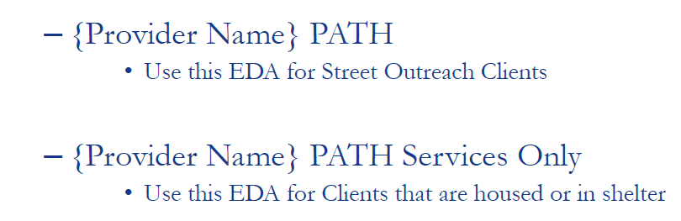
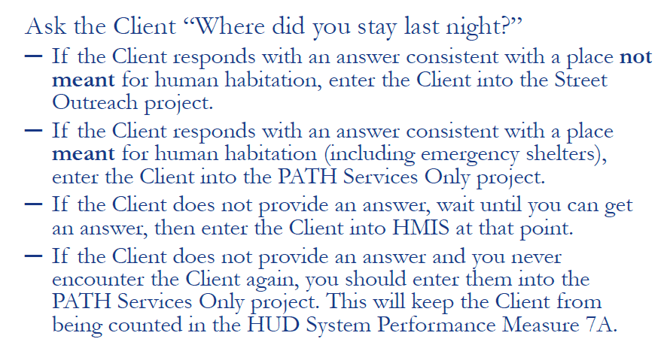

Next, you will need to search for the Client in ClientPoint. If there are no existing records, complete the fields on the ‘Client Search’ screen and click “Add New Client with this Information”. Select Option 1 – Add Client Only.
Once in the Client Record, navigate to the ‘Entry/Exit’ tab and click “Add Entry/Exit”. Complete the required HUD Data Elements on the Entry assessment and click “Save”. Scroll back up and complete the Zip Code and ROI fields on the Maine Required Data Elements assessment. Click “Save & Exit”. The Client’s Entry into the PATH Program has been completed.
For Updates to Client information, open the Client Record and navigate to the ‘Entry/Exit’ tab. Select the icon under the “Interim” column that corresponds with your Program’s Entry. Click “Add Interim Review”. The Type will be Update and the Date will be the date on which the update information was received. Makes updates to any fields on the Update assessment. As Client information may change as Services are provided and Referrals are made. Ensure all updates are recorded in HMIS as they occur.
Clients who no longer receive PATH Services or Outreach should be Exited from the PATH Program. If more than 60 days goes by since the Date of Last Contact or Service, the Client should be Exited from the PATH Program. If a Client is not Enrolled for any reason once PATH Status Determination information is recorded, an Exit from the Program should be recorded.
To do record the Exit in HMIS, open the Client Record. Navigate to the ‘Entry/Exit’ tab. Click on the pencil icon next to the “Exit Date” field that corresponds with your Program’s Entry. Complete the following required fields on the ‘Edit Exit Data” overlay screen that appears:
- Exit Date
- Reason for Leaving
- Destination
Click “Save & Continue” to proceed to the Exit assessment. Complete the Exit assessment. The Client has been successfully Exited from the PATH Program.
